M.C. WILLIAMS MIDDLE PRESENTS
LOVE OUR GARDEN
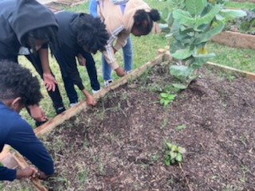
COMMUNITY SERVICE PROGRAM
WHEN: FEBRUARY 18, 2023
WHERE: WOLVERINE PATCH (M.C. WILLIAMS GARDEN)
TIME: 9:00AM – 12:OO PM
Please wear appropriate attire to work in the garden
(pants, shirts, closed-toe shoes, gloves).
Refreshments will be served.

